

.NET PRACTICAL

Hepi Chaniyara

160470107008

VVPCE .NET SEM-6

160470107008

Table of Contents

PRACTICAL:1 1

PRACTICAL:2 8

Program 1 8

Program 2 9

Program 3 10

Program 4 12

PRACTICAL:3 15

Program 1 15

Program 2 18

PRACTICAL:4 21

PRACTICAL:5 24

Program 1: 24

Program 2 24

Program 3: 25

PRACTICAL:6 26

Program 1: 26

PRACTICAL:7 29

Program 1: 29

PRACTICAL:8 32

Program 1: 32

Program 2: 34

VVPCE .NET SEM-6
160470107008 INTRODUCTION TO C#

PRACTICAL:1

AIM: INTRODUCTION TO C#

Variables:

Initialization

Scope

Constant

Predefined Data Types

Value Types

Reference TYpes

Flow Control

Conditional Statements(if, switch)

Loop(for, while, dowhile, foreach)

Jump(goto, break, continue, return)

Eumerations

Passing Arguments

using System;

using System.Collections.Generic;

using System.Linq;

using System.Text;

using System.Threading.Tasks;

namespace aim

{

class Program

{

static int newint=100;

public enum TimeOfDay

{

Morning = 0,

Afternoon = 1,

Evening = 2

VVPCE .NET SEM-6
160470107008 INTRODUCTION TO C#

}

public static void Main(string[] args)

{

Console.WriteLine("\n integer types");

sbyte sb = 10;

short s = 33;

int i = 10;

long l = 33L;

byte b = 22;

ushort us = 33;

uint ul = 33u;

ulong ulo = 33ul;

Console.WriteLine("{0},{1},{2},{3},{4},{5},{6},{7}", sb, s, i, l, b, us, ul, ulo);

float f = 1.122345656767f;

double d = 12.1234455657878797;

Console.Write("\nFloat and Double:\n");

Console.WriteLine("{0} and \n{1}", f, d);

decimal dec=111.666666666666666666666M;

Console.WriteLine("decimal:\n{0} ",dec);

Console.WriteLine("\nBoolean:");

bool boolean =true;

Console.WriteLine("Status: " + boolean);

- Console.ReadLine();

char character ='d';

Console.WriteLine(character);

character = '\0';

Console.WriteLine("Now null: " + character);

object o1 = "Hi, I am ALICE";

object o2 = 15.3454365;

string strObj = o1 as string;

Console.WriteLine(strObj);

Console.WriteLine(o1.GetHashCode() + " " + o1.GetType());

Console.WriteLine(o2.GetHashCode() + " " + o2.GetType());

VVPCE.NET SEM-6 Page 2
160470107008 INTRODUCTION TO C#

Console.WriteLine(o1.Equals(o2));

string s1, s2;

s1 = "this is string";

s2 = s1;

Console.WriteLine("S1 is: {0} and s2 is {1}", s1, s2); s2 = "other string";

Console.WriteLine("S1 is: {0} and s2 is {1}", s1, s2); s1 = "c:C:\\Users\\Dell\\source\\repos\\aim"; Console.WriteLine(s1);

s1 = @"c:C:\Users\Dell\source\repos\aim\aim"; Console.WriteLine(s1);

s1 = @"We can also write

like this";

Console.WriteLine(s1);

bool isZero;

Console.WriteLine("\nFlow Control: (if)\ni is " + i);

if (i == 10)

{

isZero = true;

Console.WriteLine("i is Zero {0}",isZero);

}

else

{

isZero = false;

Console.WriteLine("i is Non - zero");

}

int integerA = 1;

Console.WriteLine("\nSwitch:");

switch (integerA)

{

case 1:

Console.WriteLine("integerA = 1");

break;

case 2:

VVPCE.NET SEM-6 Page 3
160470107008 INTRODUCTION TO C#

Console.WriteLine("integerA = 2");

//goto case 3;

break;

case 3:

Console.WriteLine("integerA = 3");

break;

default:

Console.WriteLine("integerA is not 1, 2, or 3");

break;}

WriteGreeting(TimeOfDay.Morning);

Console.WriteLine("Argument is: {0}",args[1]);

void WriteGreeting(TimeOfDay timeOfDay)

{

switch (timeOfDay)

{

case TimeOfDay.Morning:

Console.WriteLine("Good morning!");

break;

case TimeOfDay.Afternoon:

Console.WriteLine("Good afternoon!");

break;

case TimeOfDay.Evening:

Console.WriteLine("Good evening!");

break;

default:

Console.WriteLine("Hello!");

break;

} }

Console.WriteLine("Scope of Variables.\n1:"); int newint=0;

int j;

for (/*int*/ j = 0; j < 2; j++) //removing comment from for loop will

raise error

VVPCE.NET SEM-6 Page 4
160470107008 INTRODUCTION TO C#

{

//int j;

//uncomment above line to error "A local variable named 'j' cannot be declared in this

//scope because it would give a different meaning to 'j', which is

already

//used in a 'parent or current' scope to denote something else"

Console.Write("{0} {1}\n", newint, Program.newint);

}

Console.WriteLine("2:");

for (int k = 0; k < 3; k++)

{

Console.Write("{0} ", k);

}//Scope of k ends here

Console.Write("\n");

//Console.Write(k);

//uncomment above line to see error "The name 'k' does not exist in the current context"

for (int k = 3; k > 0; k--)

{

Console.Write("{0} ", k);

}//scope of k ends here again

Console.WriteLine("Constants");

const int valConst = 100; // This value cannot be changed. Console.WriteLine("{0} is constant value", valConst); //valConst = 45;

//uncomment above line to see error "The left-hand side of an assignment must be a variable, property or indexer"

//const only allow constant variables into the expression const int valConst2 = valConst + 9 /* + j*/;

//remove comments from the above line to see error "The expression being assigned to 'valConst2' must be constant"

Console.WriteLine("Another Constant: {0}", valConst2);

VVPCE.NET SEM-6 Page 5
160470107008 INTRODUCTION TO C#

Console.WriteLine("\nPredefined Data Types\n\nValue Types and Reference Types");

//Value Types

int vali = 2, valj = vali;

Console.WriteLine("vali is: {0} and valj is: {1}", vali, valj);

valj = 90;

Console.WriteLine("vali is: {0} and valj is: {1}", vali, valj);

//Referece Types

Vector x, y;

x = new Vector();

x.value = 3;

y = x;

Console.WriteLine("x is: {0} and y is:{1}", x.value, y.value);

y.value = 234;

Console.WriteLine("x is: {0} and y is:{1}", x.value, y.value);

//If a variable is a reference, it is possible to indicate that it does not refer to any object by setting its value to null:

y = null;

//Console.Write("Value for y is: " + y.value);

//uncomment above line to see runtime exception "System.NullReferenceException: Object reference not set to an instance of an object."

//CTS }

public class Vector

{

public int value;

}

}

}

VVPCE.NET SEM-6 Page 6
160470107008 INTRODUCTION TO C#
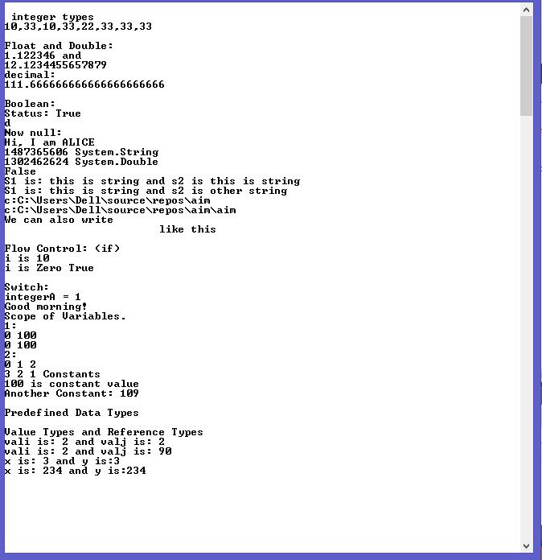

VVPCE.NET SEM-6 Page 7
160470107008 INHERITANCE

PRACTICAL:2

Program 1

Write console based program in code behind language VB or C# to print following pattern.

@ @ @ @ @

@ @ @ @

@ @ @

@ @

@

using System;

using System.Collections.Generic;

using System.Linq;

using System.Text;

using System.Threading.Tasks;

namespace practical2

{

class Program

{

static void Main(string[] args)

{

for(int i=5;i>0;i--)

{

for (int j = i; j > 0; j--)

{

Console.Write("@");

}

Console.WriteLine(" ");

}

Console.ReadKey();

}

}

}

VVPCE .NET SEM-6
160470107008 INHERITANCE
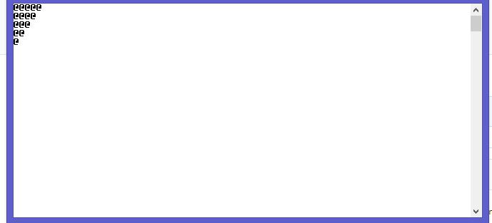

Program 2

Write console based program in code behind language VB or C# to print following pattern.

1

- 2

- 2 3

- 2 3 4

using System;

using System.Collections.Generic;

using System.Linq;

using System.Text;

using System.Threading.Tasks;

namespace practical2._1

{

class Program

{

static void Main(string[] args)

{

for(int i=1;i<=5;i++)

VVPCE.NET SEM-6 Page 9
160470107008 INHERITANCE

{

for(int j=i;j>0;j--)

{

Console.Write("{0}",i);

}

Console.WriteLine("");

}

Console.ReadKey();

}

}

}
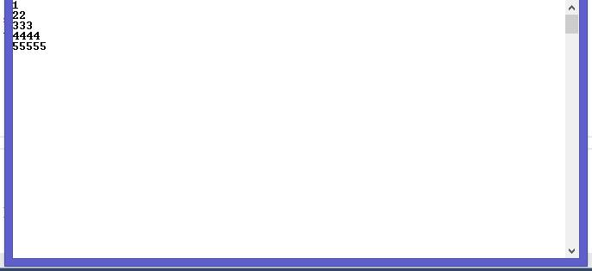

Program 3

Write C# code to prompt a user to input his/her name and country name and then the output will be shown as an example below:

Hello Ram from country India

using System;

using System.Collections.Generic;

using System.Linq;

using System.Text;

using System.Threading.Tasks;

namespace practical2._2

{

VVPCE.NET SEM-6 Page 10
160470107008 INHERITANCE

class Program

{

static void Main(string[] args)

{

string name;

string country;

Console.WriteLine("enter your name:");

name=Console.ReadLine();

Console.WriteLine("enter your country:");

country = Console.ReadLine();

Console.WriteLine("hello {0} from country {1}",name,country);

Console.ReadKey();

}

}

}
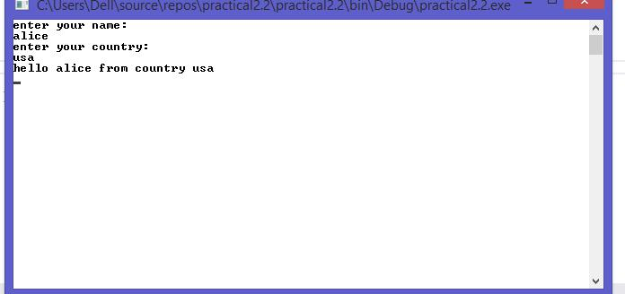

VVPCE.NET SEM-6 Page 11
160470107008 INHERITANCE

Program 4

What is inheritance? Create C# console application to define Car class and derive Maruti and Mahindra from it to demonstrate inheritance.

using System;

using System.Collections.Generic;

using System.Linq;

using System.Text;

using System.Threading.Tasks;

namespace practical2._3

{

class car

{

public void Method1()

{

Console.WriteLine("this is the method of car class");

}

}

class maruti:car

{

public void method2()

{

Console.WriteLine("this is the method of maruti");

Console.ReadKey();

}

}

class mahindra:car

{

public void method3()

{

VVPCE.NET SEM-6 Page 12
160470107008 INHERITANCE

Console.WriteLine("this is the method of mahindra");

}

}

class Program

{

static void Main(string[] args)

{

mahindra m = new mahindra();

maruti m1 = new maruti();

m.Method1();

m1.Method1();

Console.ReadKey();

}

}

}
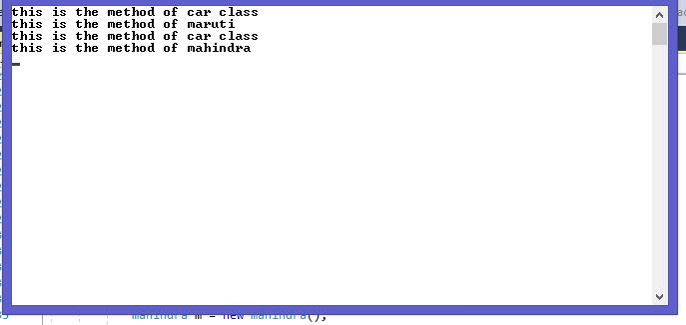

VVPCE.NET SEM-6 Page 13
160470107008 METHOD AND CONSTRUCTOR OVERLOADING

PRACTICAL:3

AIM: Method & constructor overloading Program 1

Write a c# program to add two integers, two vectors and two metric using method overloading.

using System;

using System.Collections.Generic;

using System.Linq;

using System.Text;

using System.Threading.Tasks;

namespace p3

{

public class Add

{

public void add()

{

int[,] m1 = new int[50, 50]; int[,] m2 = new int[50, 50]; int[,] m3 = new int[50, 50]; Console.WriteLine("enter size of array:");

int size = Convert.ToInt32(Console.ReadLine()); Console.WriteLine("enter first array:"); for (int i = 0; i < size; i++)

{

for (int j = 0; j < size; j++)

{

m1[i, j] = Convert.ToInt32(Console.ReadLine());

}

}

Console.WriteLine("enter second array:");

for (int i = 0; i < size; i++)

{

for (int j = 0; j < size; j++)

VVPCE .NET SEM-6
160470107008 METHOD AND CONSTRUCTOR OVERLOADING

{

m2[i, j] = Convert.ToInt32(Console.ReadLine());

}

}

for (int i = 0; i < size; i++)

{

for (int j = 0; j < size; j++)

{

m3[i, j] = m1[i, j] + m2[i, j];

}

}

Console.WriteLine("addition array:");

for (int i = 0; i < size; i++)

{

Console.Write("\n");

for (int j = 0; j < size; j++)

{

Console.Write("{0}\t", m3[i, j]);

}

Console.Write("\n");

}

}

public int add(int a, int b)

{

return (a + b);

}

}

public class Vector

{

public void add()

{

Console.WriteLine("enter first vector"); int x = Convert.ToInt32(Console.ReadLine());

VVPCE.NET SEM-6 Page 16
160470107008 METHOD AND CONSTRUCTOR OVERLOADING

int y = Convert.ToInt32(Console.ReadLine());

int z = Convert.ToInt32(Console.ReadLine());

Console.WriteLine("enter second vector");

int x1 = Convert.ToInt32(Console.ReadLine());

int y1 = Convert.ToInt32(Console.ReadLine());

int z1 = Convert.ToInt32(Console.ReadLine());

int x2 = x + x1;

int y2 = y + y1;

int z2 = z + z1;

Console.WriteLine("<" + x2 + "," + y2 + "," + z2 + ">");

}

}

class Program

{

static void Main(string[] args)

{

Add a1 = new Add();

Vector v1 = new Vector();

v1.add();

a1.add();

int res=a1.add(1, 2);

Console.Write("method overloading for addtion{0}",res);

Console.ReadLine();

}

}

}

VVPCE.NET SEM-6 Page 17
160470107008 METHOD AND CONSTRUCTOR OVERLOADING
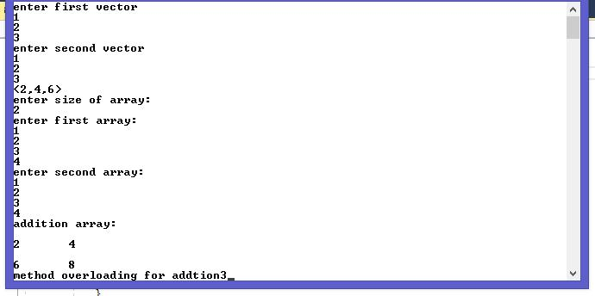

Program 2

Write a c# program that create student object. Overload constror to create new instant with following details.

- Name

- Name, Enrollment

- Name, Enrollment, Branch

using System;

using System.Collections.Generic;

using System.Linq;

using System.Text;

using System.Threading.Tasks;

using System.Reflection;

namespace p3a1

{

class Program

{

public int ID { get; set; }

VVPCE.NET SEM-6 Page 18

160470107008

METHOD AND CONSTRUCTOR OVERLOADING

public string Name { get; set; }

String name, branch;

int enrol;

public Program(String name)

{

this.name = name;

Console.WriteLine("constructor 1:" + name);

}

public Program(String name, int enrol)

{

this.name = name;

this.enrol = enrol;

Console.WriteLine("constructor 2:" + name + " " + enrol);

}

public Program(String name, int enrol, String branch)

{

this.name = name;

this.enrol = enrol;

this.branch = branch;

Console.WriteLine("constructor 3:" + name + " " + enrol + " " +

branch);

}

static void Main(string[] args)

{

Program p1 = new Program("bob");

Program p2 = new Program("bob", 1);

Program p3 = new Program("bob", 1, "computer");

Console.ReadLine();

}

}

}

VVPCE.NET SEM-6 Page 19

160470107008 METHOD AND CONSTRUCTOR OVERLOADING
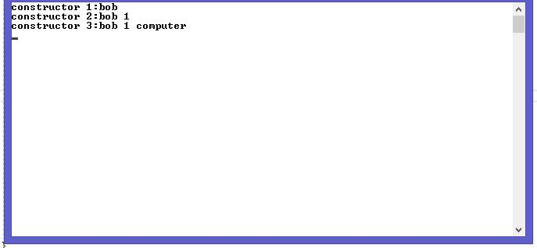

VVPCE.NET SEM-6 Page 20
160470107008 REFLECTION

PRACTICAL:4

Create a c# program to find Methods, Properties and Constructors from class of running program.(Use Class from previous practical)

using System.Collections.Generic;

using System.Linq;

using System.Text;

using System.Reflection;

using System;

namespace p2

{

class P4

{

public static void Main() {

Type T = Type.GetType("p2.Example");

MethodInfo[] methods = T.GetMethods();

foreach (MethodInfo method in methods)

{

Console.WriteLine(method.ReturnType + " " + method.Name);

}

PropertyInfo[] properties = T.GetProperties();

Console.WriteLine("\nProperties");

foreach (PropertyInfo property in properties)

{

Console.WriteLine(property.PropertyType + " " + property.Name);

}

Console.WriteLine("\nConstructors"); ConstructorInfo[] constructors = T.GetConstructors(); foreach (ConstructorInfo constructor in constructors) {

Console.WriteLine(constructor.ToString());

}

VVPCE.NET SEM-6 Page 21
160470107008 REFLECTION

}

}

class Example {

public string name { get; set; }

public int enrollment { get; set; }

public string branch { get; set; }

public Example() { }

public Example(int enrollment, string name) { this.enrollment = enrollment; this.name = name;

}

public Example(int enrollment, string name,string branch)

{

this.enrollment = enrollment;

this.name = name;

this.branch = branch;

}

public void displayName() { Console.WriteLine("Name={0}",this.name);

}

public void displayEnroll() { Console.WriteLine("Enrollment={0}",this.enrollment);

}

public void displayBranch()

{

Console.WriteLine("Branch={0}", this.branch);

}

}

}

OUTPUT:

System.Int32 get_ID System.Void set_ID

System.String get_Name System.Void set_Name

System.Void printID

System.Void printName System.String ToString

System.Boolean Equals System.Int32 GetHashCode System.Type GetType

Properties

VVPCE.NET SEM-6 Page 22
160470107008 REFLECTION

System.Int32 ID System.String Name

Constructors

Void .ctor(Int32, System.String) Void .ctor()

VVPCE.NET SEM-6 Page 23
160470107008 FILE HANDLING

PRACTICAL:5

AIM : File Handling

Program 1:

Write a C# program to copy data from one file to another using StreamReader and StreamWriter class.

using System;

using System.Collections.Generic;

using System.Linq;

using System.Text;

using System.IO;

namespace p2

{

class P4_1

{

public static void Main(){

string f1 = @"f1.txt";

string f2 = @"f2.txt";

using (StreamReader reader = new StreamReader(f1))

using (StreamWriter writer = new StreamWriter(f2))

writer.Write(reader.ReadToEnd());

}

}

}

VVPCE.NET SEM-6 Page 24
160470107008 FILE HANDLING

Program 2:

Write a C# Program to Read Lines from a File until the End of File is reached.

using System;

using

System.Collections.Generic;

using System.Linq;

using System.Text;

using System.IO;

namespace P2

{

public class CopyFile

{

public void copyFile(string f1, string f2)

{

using (StreamReader reader = new StreamReader(f1))

using (StreamWriter writer = new StreamWriter(f2))

{

string line = null;

while ((line = reader.ReadLine()) != null)

writer.WriteLine(line);

}

}

}

public class mmain{

public static void
Main(){

CopyFile cp = new CopyFile();

string f1 = @"E:\Sem-6\VS\p2\p2\f1.txt";

string f2 = @"E:\Sem-6\VS\p2\p2\f2.txt";

cp.copyFile(f1,f2);

}

}

}

VVPCE .NET SEM-6
160470107008 FILE HANDLING

Program 3:

Write a C# Program to List Files in a Directory.

using System;

using System.Collections.Generic;

using System.Linq;

using System.Text;

using System.IO;

namespace p2

{

class ListFile

{

public static void

Main() {

string[] Directories = Directory.GetDirectories(@"E:\Sem-6\VS"); foreach (string dir in Directories)

Console.WriteLine(dir);

string[] files = Directory.GetFiles(@"E:\Sem-6\VS");

foreach (string file in

files)

Console.WriteLine(fil

e);

Console.ReadKey();

}

}

}

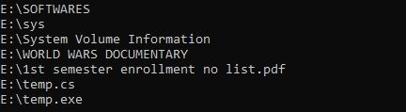

VVPCE.NET SEM-6 Page 25
160470107008 WINDOWS FORM APPLICATION

PRACTICAL:6

Program 1:

Create Windows Form Application for Student Registration and store student Details in DataBase.

using System;

using System.Collections.Generic;

using System.ComponentModel;

using System.Data;

using System.Drawing;

using System.Linq;

using System.Text;

using System.Windows.Forms;

using System.Data.SqlClient;

using System.IO;

namespace StudentForm

{

public partial class Form1 : Form

{

string imgPath;

public Form1()

{

InitializeComponent();

}

private void btnsave_Click(object sender, EventArgs e)

{

string gen = null;

string subject = null;

if (genMale.Checked == true) {

gen = "m";

}

if (genFemale.Checked == true) {

gen = "f";

}

if (ck1.Checked == true) {

subject = subject + " s1";

}

if (ck2.Checked == true) {

subject = subject + " s2";

}

string source = @"Data Source=Sagar\SQLExpress;Initial Catalog=DemoDb;Integrated Security=True;Pooling=False";

VVPCE .NET SEM-6
160470107008

string insert = "insert into tblstudent

(fname,lname,gender,subject,imgStudent) values ('" + txtfname.Text + "','" +

txtlname.Text + "','" + gen + "','" + subject + "','" + (imgPath == null ? "" :

imgPath) + "')";

//MessageBox.Show(insert);

//string insert = "insert into tblstudent(fname) values ('jhgjh')"; SqlConnection conn = new SqlConnection(source);

SqlCommand cmd = new SqlCommand(insert,conn); conn.Open();

int i = cmd.ExecuteNonQuery();

conn.Close();

}

private void Form1_Load(object sender, EventArgs e)

{

}

private void btnimg_Click(object sender, EventArgs e)

{

openFileDialog1.Filter = "Jpg|*.jpg";

if (openFileDialog1.ShowDialog() == DialogResult.OK)

{

imgPath = openFileDialog1.SafeFileName;

pictureBox.Image = Image.FromFile(openFileDialog1.FileName); //MessageBox.Show(imgPath);

}

}

}

}

Program.cs:

using System;

using System.Collections.Generic;

using System.Linq;

using System.Windows.Forms;

namespace StudentForm

{

static class Program

{

- <summary>

- The main entry point for the application.

VVPCE.NET SEM-6 Page 27
160470107008

- </summary>

[STAThread]

static void Main()

{

Application.EnableVisualStyles(); Application.SetCompatibleTextRenderingDefault(false); Application.Run(new Form1());

}

}

}

OUTPUT:
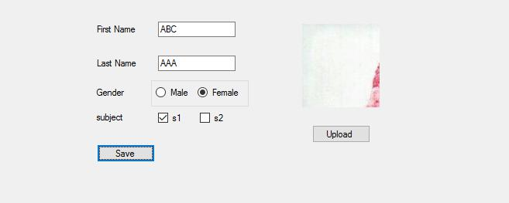

VVPCE.NET SEM-6 Page 28
160470107008

PRACTICAL:7

Program 1:

ASP.NET Validation Control

RequiredFieldValidator, CompareValidator, RegularExpressionValidator, CustomValidator, RangeValidator ,ValidationSummary

<%@ Page Title="Home Page" Language="C#" AutoEventWireup="true" CodeBehind="Default.aspx.cs" Inherits="WebApplication2._Default" %>

<form id="form1" runat="server">

<div>

<table>

<tr>

<td>

<asp:Label runat="server" Text="Name"></asp:Label>

&nbsp;&nbsp;&nbsp;&nbsp;&nbsp;&nbsp;&nbsp;&nbsp;&nbsp;&nbsp;&nbsp;&nbsp;&nbsp;&nbs p;&nbsp;&nbsp;&nbsp;&nbsp;&nbsp;&nbsp;&nbsp;&nbsp;

<asp:TextBox ID="txtname" runat="server" ></asp:TextBox> <asp:RequiredFieldValidator ID="RequiredFieldValidator1"

runat="server"

ControlToValidate="txtname"

ErrorMessage="RequiredFieldValidator"></asp:RequiredFieldValidator> <br />

</td>

</tr>

<tr>

<td>

<asp:Label ID="Email" runat="server" Text="Email"></asp:Label>

&nbsp;&nbsp;&nbsp;&nbsp;&nbsp;&nbsp;&nbsp;&nbsp;&nbsp;&nbsp;&nbsp;&nbsp;&nbsp;&nbs p;&nbsp;&nbsp;&nbsp;&nbsp;&nbsp;&nbsp;&nbsp;&nbsp;&nbsp;

<asp:TextBox ID="txtemail" runat="server"></asp:TextBox> <asp:RegularExpressionValidator

ID="RegularExpressionValidator1" runat="server"

ErrorMessage="RegularExpressionValidator"

ValidationExpression="\w+([-+.']\w+)*@\w+([-.]\w+)*\.\w+([-

.]\w+)*"

ControlToValidate="txtemail"></asp:RegularExpressionValidator>

VVPCE .NET SEM-6
160470107008 VALIDATION CONTROLS

<br />

</td>

</tr>

<tr>

<td>

<asp:Label ID="Label3" runat="server"

Text="Password"></asp:Label>

&nbsp;&nbsp;&nbsp;&nbsp;&nbsp;&nbsp;&nbsp;&nbsp;&nbsp;&nbsp;&nbsp;&nbsp;&nbsp;&nbs p;&nbsp;&nbsp;

<asp:TextBox ID="txtpass" runat="server"

TextMode="Password"></asp:TextBox>

<br />

</td>

</tr>

<tr>

<td>

<asp:Label ID="Label4" runat="server" Text="Confirm Password"></asp:Label>

&nbsp;&nbsp;&nbsp;

<asp:TextBox ID="txtcpass" runat="server"

TextMode="Password"></asp:TextBox>

<asp:CompareValidator ID="CompareValidator1" runat="server" ControlToCompare="txtcpass" ControlToValidate="txtpass" ErrorMessage="CompareValidator"></asp:CompareValidator>

<br />

</td>

</tr>

<tr>

<td>

<asp:Label ID="Label5" runat="server" Text="Sem"></asp:Label>

&nbsp;&nbsp;&nbsp;&nbsp;&nbsp;&nbsp;&nbsp;&nbsp;&nbsp;&nbsp;&nbsp;&nbsp;&nbsp;&nbs p;&nbsp;&nbsp;&nbsp;&nbsp;&nbsp;&nbsp;&nbsp;&nbsp;&nbsp;&nbsp;

<asp:TextBox ID="txtsem" runat="server"></asp:TextBox> <asp:RangeValidator ID="RangeValidator1" runat="server"

ControlToValidate="txtsem" ErrorMessage="RangeValidator"

MaximumValue="8"

MinimumValue="1"></asp:RangeValidator>

<br />

<asp:ValidationSummary ID="ValidationSummary1" runat="server"

/>

VVPCE.NET SEM-6 Page 30
160470107008 VALIDATION CONTROLS

</td>

</tr>

<tr>

<td>

<asp:Button ID="Button1" runat="server" Text="Save" /> </td>

</tr>

</table>

</div>

</form>

OUTPUT:
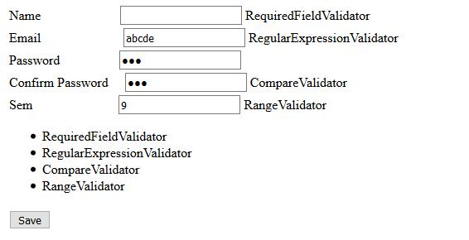

VVPCE.NET SEM-6 Page 31
160470107008 MASTER PAGES

PRACTICAL:8

AIM: Introduction to Master Pages

Program 1:

Site1.Master:

using System;

using System.Collections.Generic;

using System.Linq;

using System.Web;

using System.Web.UI;

using System.Web.UI.WebControls;

namespace WebApplication1

{

public partial class Site1 : System.Web.UI.MasterPage {

protected void Page_Load(object sender, EventArgs e)

{

}

public Label LblHeader {

get {

return lblheader;

}

}

public Button BtnSearch {

get {

return btnsearch;

}

}

public TextBox TxtSearch {

get {

return txtsearch;

}

}

}

}

WebForm1.aspx:

<%@ Page Title="" Language="C#" MasterPageFile="~/Site1.Master" AutoEventWireup="true" CodeBehind="WebForm1.aspx.cs" Inherits="WebApplication1.WebForm1" %>

VVPCE .NET SEM-6
160470107008 MASTER PAGES

<asp:Content ID="Content1" ContentPlaceHolderID="ContentPlaceHolder1" runat="server">

<asp:TextBox ID="txtname" runat="server" ></asp:TextBox>

<asp:Button ID="Button1" runat="server" Text="Set Header" onclick="Button1_Click"

/>

</asp:Content>

WebForm.aspx.cs:

using System;

using System.Collections.Generic;

using System.Linq;

using System.Web;

using System.Web.UI;

using System.Web.UI.WebControls;

namespace WebApplication1

{

public partial class WebForm1 : System.Web.UI.Page {

protected void Page_Load(object sender, EventArgs e)

{

}

protected void Button1_Click(object sender, EventArgs e)

{

((Site1)Master).LblHeader.Text = txtname.Text;

}

}

}

OUTPUT:
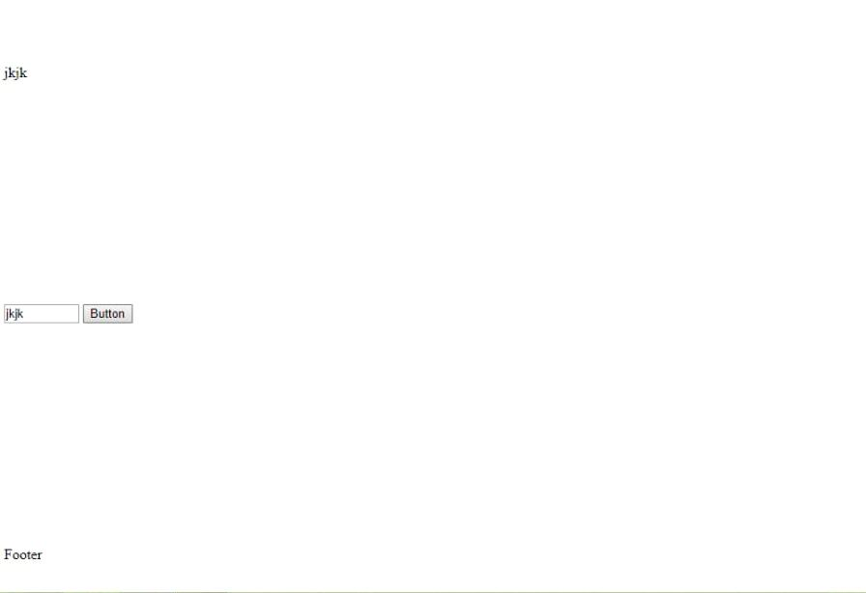

VVPCE.NET SEM-6 Page 33
160470107008 MASTER PAGES

Program 2:

WebForm2.aspx:

<%@ Page Title="" Language="C#" MasterPageFile="~/Site1.Master" AutoEventWireup="true" CodeBehind="WebForm2.aspx.cs" Inherits="WebApplication1.WebForm2" %>

<asp:Content ID="Content2" ContentPlaceHolderID="ContentPlaceHolder1" runat="server">

<asp:GridView ID="grdstudent" runat="server">

</asp:GridView>

</asp:Content>

WebForm2.aspx.cs:

using System;

using System.Collections.Generic;

using System.Linq;

using System.Web;

using System.Web.UI;

using System.Web.UI.WebControls;

using System.Data.SqlClient;

namespace WebApplication1

{

public partial class WebForm2 : System.Web.UI.Page {

protected void Page_Init(object sender, EventArgs e)

{

((Site1)Master).BtnSearch.Click += new EventHandler(BtnSearch_Click);

}

void BtnSearch_Click(object sender, EventArgs e) { getData();

}

protected void Page_Load(object sender, EventArgs e)

{

}

void getData() {

string s= ((Site1)Master).TxtSearch.Text;

Console.WriteLine(s);

string source = @"Data Source=Sagar\SQLExpress;Initial Catalog=DemoDb;Integrated Security=True;Pooling=False";

string select = "select * from tblstudent where fname like '%"+ ((Site1)Master).TxtSearch.Text + "%'";

SqlConnection con = new SqlConnection(source); SqlCommand cmd = new SqlCommand(select, con);

VVPCE.NET SEM-6 Page 34
160470107008 MASTER PAGES

con.Open();

SqlDataReader rdr = cmd.ExecuteReader();

grdstudent.DataSource = rdr;

grdstudent.DataBind();

con.Close();

}

}

}

OUTPUT:
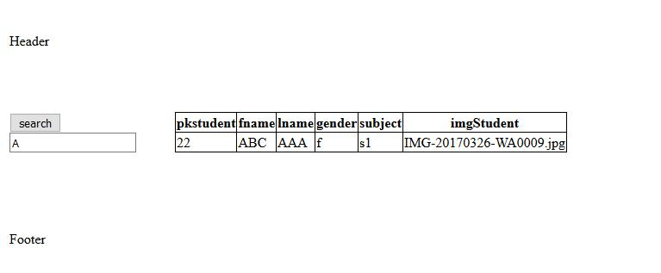

VVPCE.NET SEM-6 Page 35
160470107008 MASTER PAGES

VVPCE.NET SEM-6 Page 36

